|  |
| --- |
| **National University of Computer and Emerging Sciences** |
| In-Lab 5 Exercise  “Nested Queries” |
|  |
| Database Systems |
| Spring 2023 |

Department of Computer Science

FAST-NU, Lahore, Pakistan

**Total Time: 120 Minutes**

**Schema:**

For this exercise use the following schema, the script to create this schema and populate data is given in Twitter.SQL file.

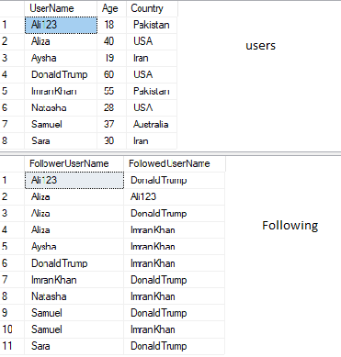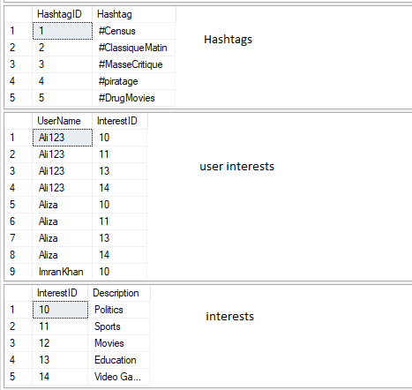

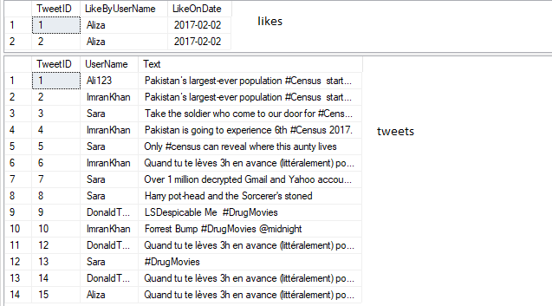

**Exercise:**

1. What is maximum, minimum, average and standard deviation of ages of the users? (Search Standard Dev function)

**Expected Output:**



1. Give name of the user who has the highest number of followers.

**Expected Output:**

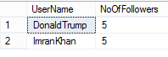

1. Give name of the user who has second highest followers.

**Expected Output:**



1. List names of all the users who have never tweeted.

**Expected Output:**

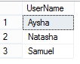

1. List all the hashtags and usernames and number of times that user used that hashtag.

**Expected Output:**

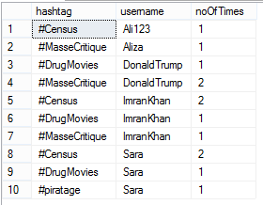

1. Find the users who have never used the hashtag #Census.

**Expected Output:**

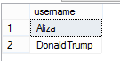

1. List all the usernames that have never been followed. Using Set operation

**Expected Output:**

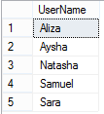

1. List all the usernames that have never been followed. Using Exist Clause.

**Expected Output:**



1. Find the most common interest of users. (The interest with largest number of users). Also find the least common interest.

**Expected Output:**

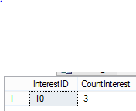

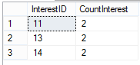

1. Show total tweets per country. The result should be in order of country name.

**Expected Output:**

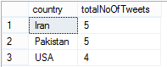

1. List names of all the users whose number of tweets is more than average number of tweets per user.

**Expected Output:**

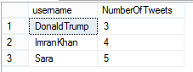

1. Give the name of the users who have at least one follower from Pakistan.

**Expected Output:**



1. Show the interest ID and description of interest with the most number of users.

**Expected Output:**

